PADONIA NEWS

February 2018

Construction Updates

Have you ever walked into the new classrooms and hallway? If you have, you know what it’s like. The News Paper Club had a sneak peak and got to talk to two kinder-garten teachers.

It took hard work from moving back and forth to their new classroom. It took two days to move in. The teacher are happy with their class rooms and don’t want to change anything. The teachers, favorite part is the lay out and colors. Also they have a smart board which looks like a big screen T.V. It does not take time from learning be-cause they have a bathroom in their classroom and they do not have to take bathroom breaks any more.

The colors of the lookers are different from the oth-er part of the school, the color is blue. Also, they have a digital clock.

By: Ethan Sullivan & Glory Akinremi

In This Issue:

- Construction Updates

    - Pre-K All Day?

  - Joke of the Month

      - Puzzles

Questions with

Mrs. DiDonato

How long do you think the renovation will take?

She thought it will take 1 yr.

How much money did it cost?

It cost 6.5 million.

What is your next idea to im-prove the school?

Improve the Parking lot .

When do you think it’s will done?

It will be finish August this year.

Who will use the new class-rooms?

The new wing of the school was for the pre-k and kindergarten. The new addition will allow Padonia to get rid of the cottages and bring all but one class in-side.

Joke of the Month

Why did the student take a ladder to school?

HIGH school!
Because he thought it was a

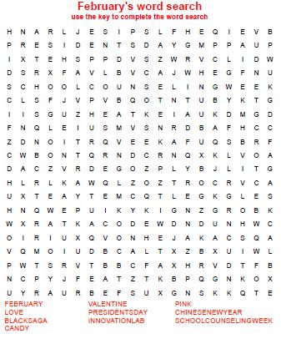

Pre-K All Day?

Do you think preschoolers should have a half day or should they stay for a full day? After speaking to 5th graders and parents some believe preschoolers should go to school for a full day because they are students just like you and I. Some other kids and parents think they should be at school for a half a day be-cause they’re still little.

A girl I interviewed named Alexandra in 5th grade said “I think it’s not fair they go to sleep early, wake up early, and then 2 hours later home again. They don’t need to be at school for a half day because I have to go to school for a full day. Why can’t they leave the same time we do? Preschooler barely learn, all they really do is play games. What’s the difference preschoolers are still stu-dents, why do they have to leave early? Are they getting special treatment?” Well she does have a point but another person I interviewed named Glory also in 5th grade had a different answer.

Glory said “the preschoolers don’t need that much learning their just kids. They need learning appropriate for their age. Most preschoolers go to sleep, wake up, and go to school early. They need time to rest and if kids get stressed they can sometimes get headaches”.

What do you think, should preschoolers have a half day or should they have a full day like other elementary school students?

By: Ariana Seda-Banks

Suggestions?

Send in your opinions or suggestions for the March issue to Mrs. Schreiber or Ms. Sanchez. This is your newspa-per. We welcome your feedback!

